Instructions for fitting wing tanks to Skyranger and Nynja aircraft.

- Carefully remove the wings from the aircraft. Ailerons and flaps can remain attached but care is required not to damage the flaps and ailerons.
- Place the wing on padded trestles or a suitable table.
- Remove the tension from tube 38 (tensioning tube) by backing off the 8mm nuts on the threaded tube.
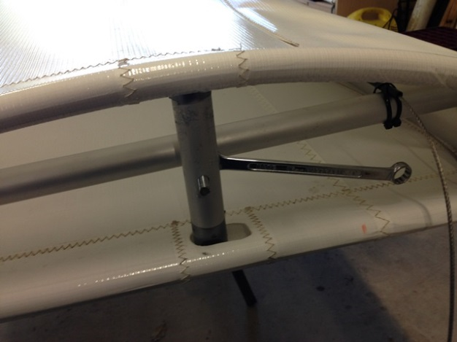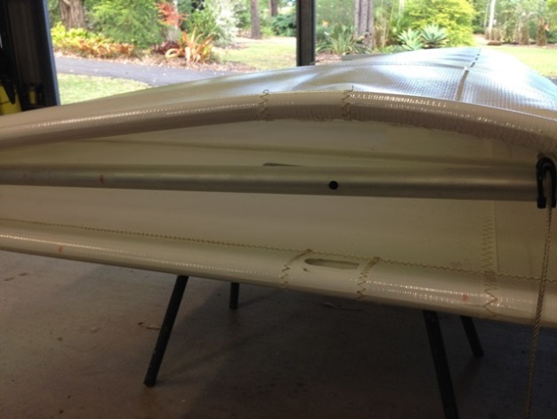
- Remove the vertical tensioning pieces
- Drill the keeper rivet or remove the screw from the metal grommet in the wing fabric at the leading edge.
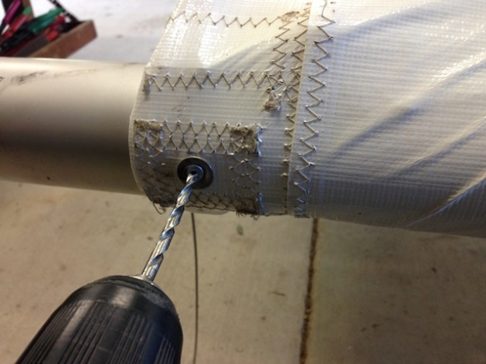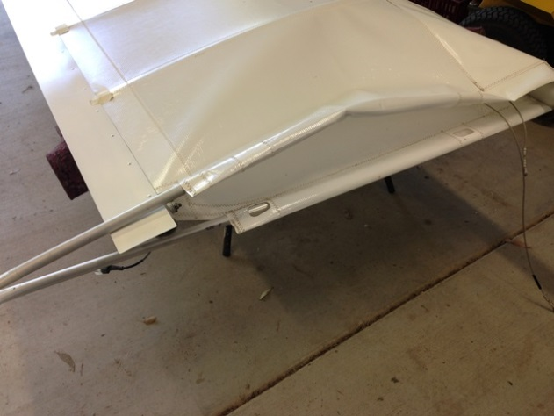
- Slide the top and bottom tensioning battens out of their pockets from the trailing edge.
- Remove tie wire from the turnbuckle on the front bracing cable and back off the tension enough to remove tube 38.
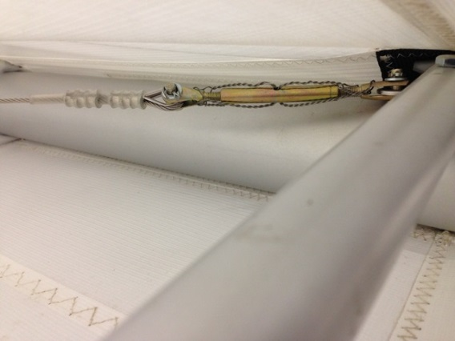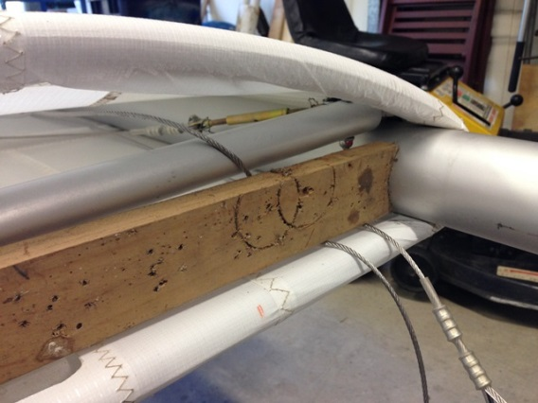
- Remove tube 38 (tensioning tube) Remember tube 38 is located by an over centre tang at the leading edge. The ideal tool for this (and essential) is a piece of timber 12mm longer than the distance between the leading and trailing wing tubes. Cut profiles of the tubes each end so it won’t slip out. Locate the “tool” on the trailing edge tube and slide the timber along the leading edge tube. This will spread the tubes enough to flick tube 38 out with the aid of a screw driver. Use the same method to reinstall the tube later.
- Push the fabric back along the leading edge tube to expose the 8mm bolt locating the tensioning tube tang and turnbuckle anchor point.
- Remove the bolt and reposition the turnbuckle to the underside of the leading edge tube. The bolt can be replaced with the rounded head at the top if desired. This reduces the distortion of the wing fabric at the root. If this is done you will need to protect the wing fabric from the nut on the underside of the tube. Replace the nut with a new Nyloc and remember the Loctite.
- Relocate both bracing cables to pass underneath tube 37.
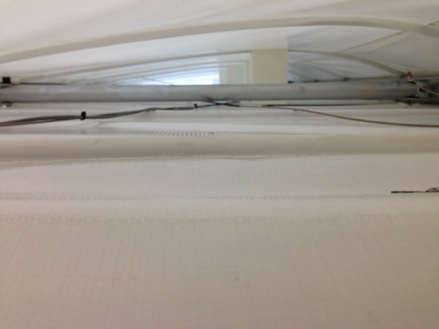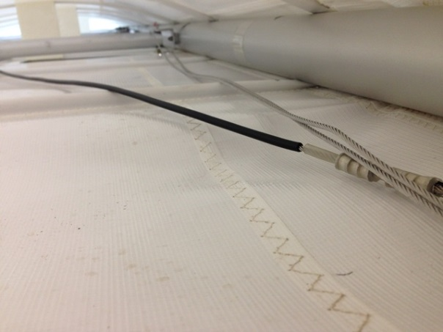
- Split some plastic tubing and slide it along the bracing cables. This will prevent chaffing as the cables will pass directly under the wing tank. 4mm irrigation tube is perfect for this.
- Slide the first two lower wing battens out from the trailing edge of the wing. This will make it easier to slide the tanks in. The wing is now ready to accept the tanks.
- Fit the supplied foam tape to the upper and lower edges of the tank.
- Fit the pinchweld to the mounting brackets.
- Fit the collar to the fuel filler (optional) and fit the brass hose fittings to the tank with either Teflon tape or Loctite. Fit the vent tube now as it is much harder to do later.
- Fit the locating clamps around tube 37. Much easier to do it before the tanks are fitted.
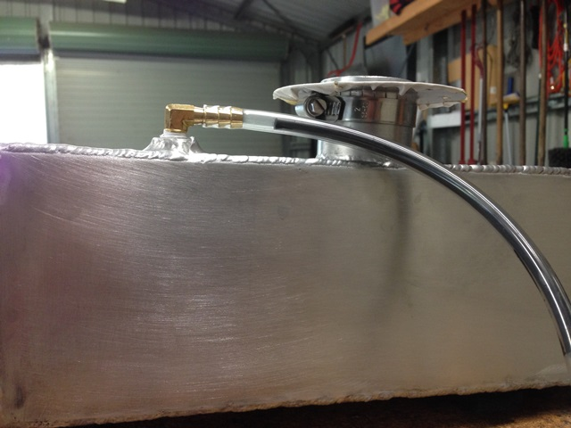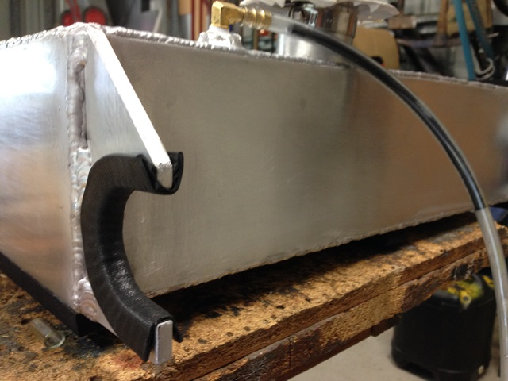
18. As the fuel tank is insulated a static wire will have to be fitted. At least drill and tap the mounting hole before the tank is fitted.
19.Gently slide the tank into the wing being careful not to snag the bracing cables with the tank mounting brackets. The front of the tank should be just to the rear of the fabric seam line. Make sure the tank locates properly both front and back onto tube 37. The tank filler should be pressing up a little into the wing fabric.
20. Re-fit the keeper rivet or screw in the wing fabric metal gromet.
21. Re fit Tube 38 (tensioning tube) with your special wooden tool. Making sure the tube slots into the tank mounting bracket.
22. Re-fit the top and bottom tensioning battens. Make sure they fit snugly back into their pockets.
23. Re-fit the vertical tensioning tubes with the longer end to the top. Re-tension the wing fabric with the 8mm nuts on the inside of the vertical tensioning tubes. This will in turn clamp the tank between tube 37 and 38.
24. Fit the locating clamps to both ends of the tank.
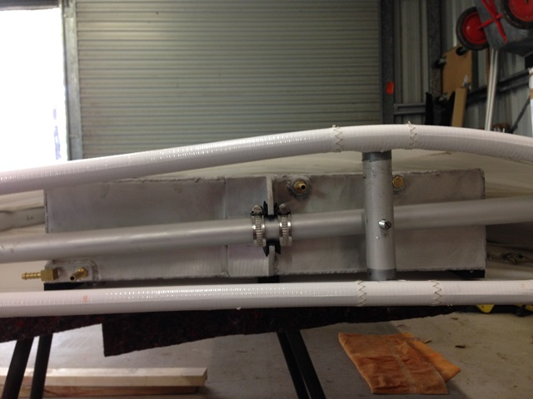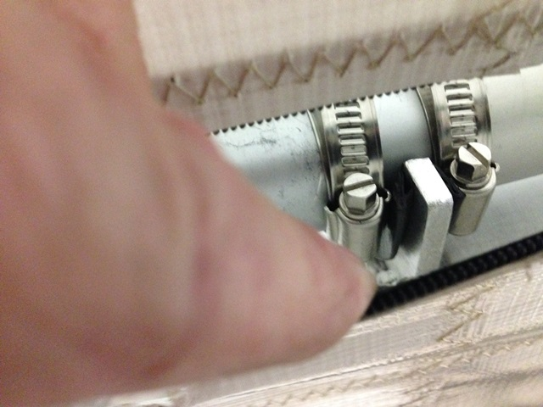
25. Slide the lower wing battens removed previously back into place.
26. Fit a Dacron re-enforcing patch over the fuel filler. With a sharp knife cut the fabric on the inside of the fuel filler .
27. Fit the top collar (optional) in place and rivet it through the fabric to the lower collar. Fit the fuel filler cap.
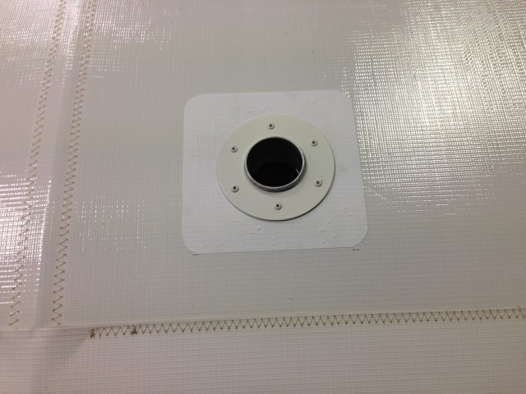
28. Tension the bracing cable with the turnbuckle and lock wire the turnbuckle. Nimble fingers required.
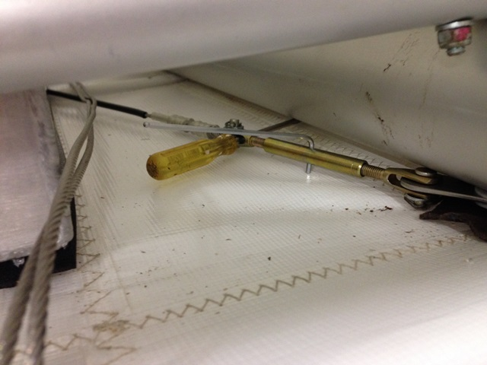
29. The brass fitting right at the rear of the tank is the fuel feed to the engine. The fitting just in front of this and the fitting at the top of the tank just forward of the mounting bracket are for the sight tube. I recommend a fuel cock be fitted to both tanks.
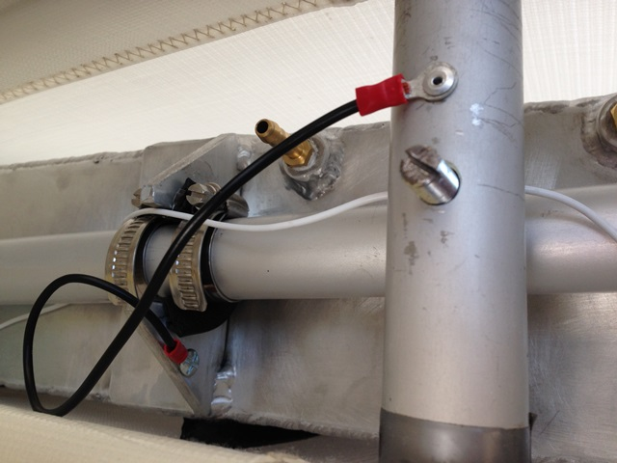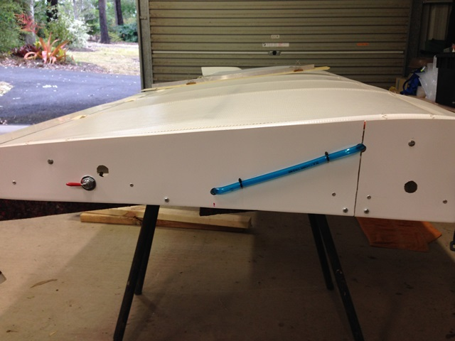
30. Burn a hole in the lower wing fabric with a hot iron and fit the fuel drain valve. The wing can now be refitted to the aircraft, and you can now do it all again with the second wing.
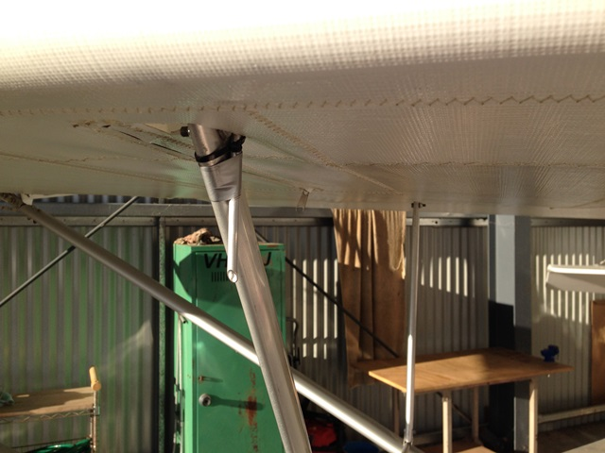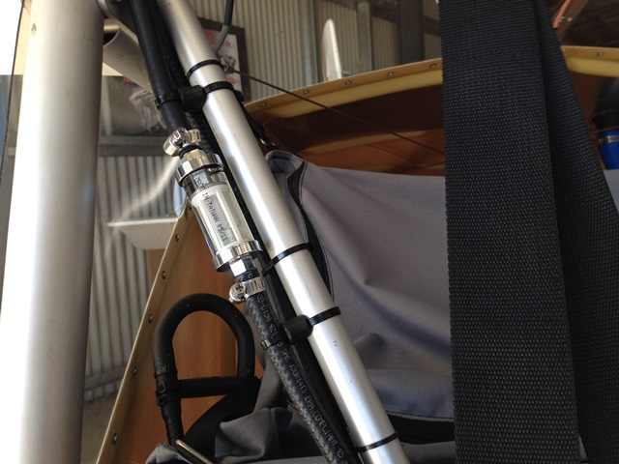
31. Location of vent tube above. Make certain the tube is cut at an angle and the cut facing the air stream. This will provide a little positive vent pressure.
Notes.
You will have to re-weigh your aircraft and modify your Weight and balance tables. All work done on your aircraft should be written up in your aircraft maintenance log book. Please get another pilot to check your aircraft thoroughly especially the control cables before flight.
The wing tanks and associated hardware weigh +/- 10 kg. Most of the 90 litre aluminium tanks weigh +/- 14kg so you save a little. The standard plastic tanks weigh around 4 kg.
The wing tanks have a capacity of 52 litres each side. You may choose to fit a small header tank, this will of course increase your fuel capacity.
MTOW remains at 540 kg. Your aircraft should never be flown overloaded.

